

ISLAMIC UNIVERSITY OF TECHNOLOGY (IUT)
ORGANISATION OF ISLAMIC COOPERATION (OIC)
Department of Computer Science and Engineering (CSE)

QUIZ 2 STATISTICS

Average Breakdown

Problem |  | Avg | Out of | Percentage  (%) | Avg | Out of | Percentage  (%)
5 variable Kmap |  | 2.67 | 5 | 53.45 | 2.67 | 5 | 53.45
Tabular Method | Binary Representation | 0.97 | 1 | 96.98 | 9.16 | 11 | 83.27
 | Binary Group | 0.97 | 1 | 96.98
 | Matching Table | 5.21 | 6 | 86.85
 | PI | 1.41 | 2 | 70.69
 | EPI | 0.59 | 1 | 59.48
Cut and Try | Simplification | 0.85 | 2 | 42.46 | 1.49 | 4 | 37.18
 | Universal Gate | 0.64 | 2 | 31.90
Total |  | 13.32 | 20 | 66.60 | 13.32 | 20 | 66.60

Attempts

Problem |  |  | Out of | Percentage
5 variable Kmap |  | 52 | 58 | 89.66
Tabular Method | Binary Representation | 55 |  | 94.83
 | Binary Group | 55 |  | 94.83
 | Matching Table | 55 |  | 94.83
 | PI | 53 |  | 91.38
 | EPI | 46 |  | 79.31
Cut and Try | Simplification | 44 |  | 75.86
 | Universal Gate | 36 |  | 62.07

Performance Graph

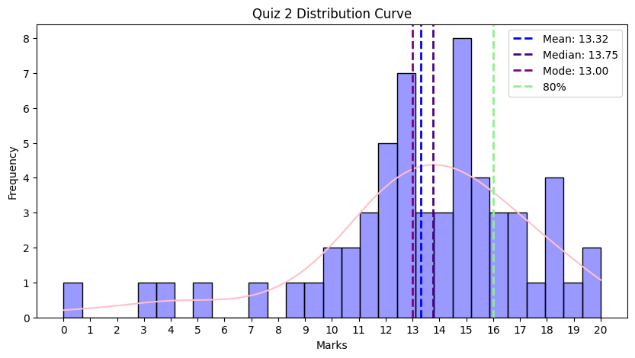

Full Marks
Problem |  | Count | Percentage | Count | Percentage | Out of
5 variable Kmap |  | 2 | 3.45 | 2 | 3.45 | 58
Tabular Method | Binary Representation | 54 | 93.10 | 19 | 32.76
 | Binary Group | 54 | 93.10
 | Matching Table | 33 | 56.90
 | PI | 27 | 46.55
 | EPI | 24 | 41.38
Cut and Try | Simplification | 12 | 20.69 | 8 | 13.79
 | Universal Gate | 7 | 12.07
Total |  | 1 | 1.72

Leaderboard

Serial | ID | Name | Marks
1 | 230042135 | Khadiza Sultana | 20
2 | 230042117 | M Safwan Hasan Khan | 19.5
3 | 230042110 | S. M. Samiul Hossain | 19
4 | 230042111 | Md. Ashraful Abedin | 18.5
5 | 230042116 | Md. Atik Shahriar | 18.5
6 | 230042101 | Mahmudul Hossain Samir | 18
7 | 230042112 | Ifham Bin Hossain | 18

Comebacks
Serial | ID | Name | Improvement | Percentage
1 | 230042116 | Md. Atik Shahriar | 13.5 | 67.5
2 | 230042117 | M Safwan Hasan Khan | 8.5 | 42.5
3 | 230042146 | Md Nadid Hassan Khan | 8.5 | 42.5
4 | 230042119 | Talha Zubayer | 7 | 35
5 | 230042107 | Md. Faiyaz Tahmid | 6 | 30
6 | 230042121 | Md Rufayed Ul Alam | 6 | 30
7 | 230042131 | Tabib Hassan | 6 | 30
8 | 230042112 | Ifham Bin Hossain | 5.5 | 27.5
9 | 230042149 | Asif Al Azad | 5.5 | 27.5

Unnecessary Statistics
- 1 student got a perfect score.
- 38 students got more in quiz 2 than quiz 1.
- Someone got 0.
- Quiz Average increased by 1.12 marks or 5.4% (from 12.24 to 13.32).
- Bonus –
  - If you attended the quiz and you didn’t get 0 → bonus 0.25 attendance mark.
  - If you attended the quiz and got more than the class average → bonus 0.5 attendance mark.
  - If you attended the quiz and got more than 80% marks (16) → bonus 1 attendance mark.

Few Things to be noted
- Read the question carefully.

